

**STEP 1:**

**On the duration of completing the Niyo Bootcamp, I wanted my final project to be based on crime and offences within the USA. I found this dataset on Kaggle.**

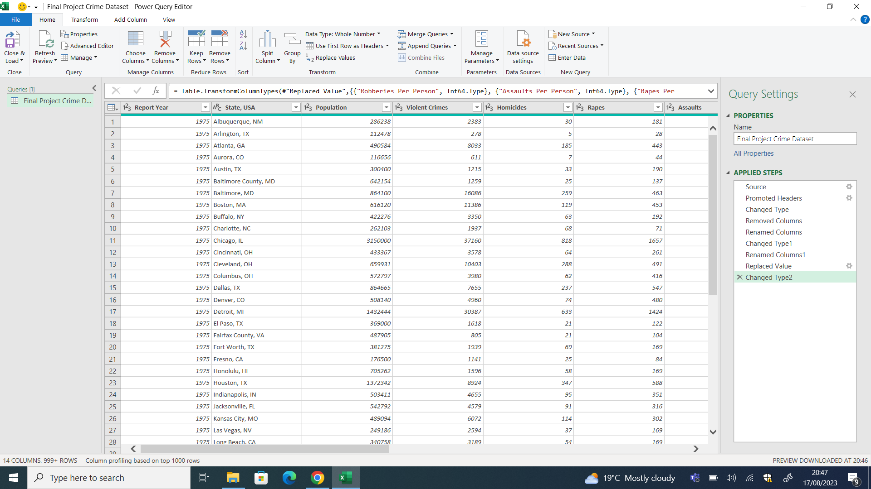

**STEP 2:**

**After choosing the dataset to work on for my final project I began cleaning the data on PowerQuery.**

**I completed the following steps:**

* **Deleting null value columns**
* **Promoted Headers**
* **Changed Type**
* **Removed Columns**
* **Renamed Columns**
* **Changed Type1**
* **Renamed Columns1**
* **Replaced Values**
* **Changed Type2**

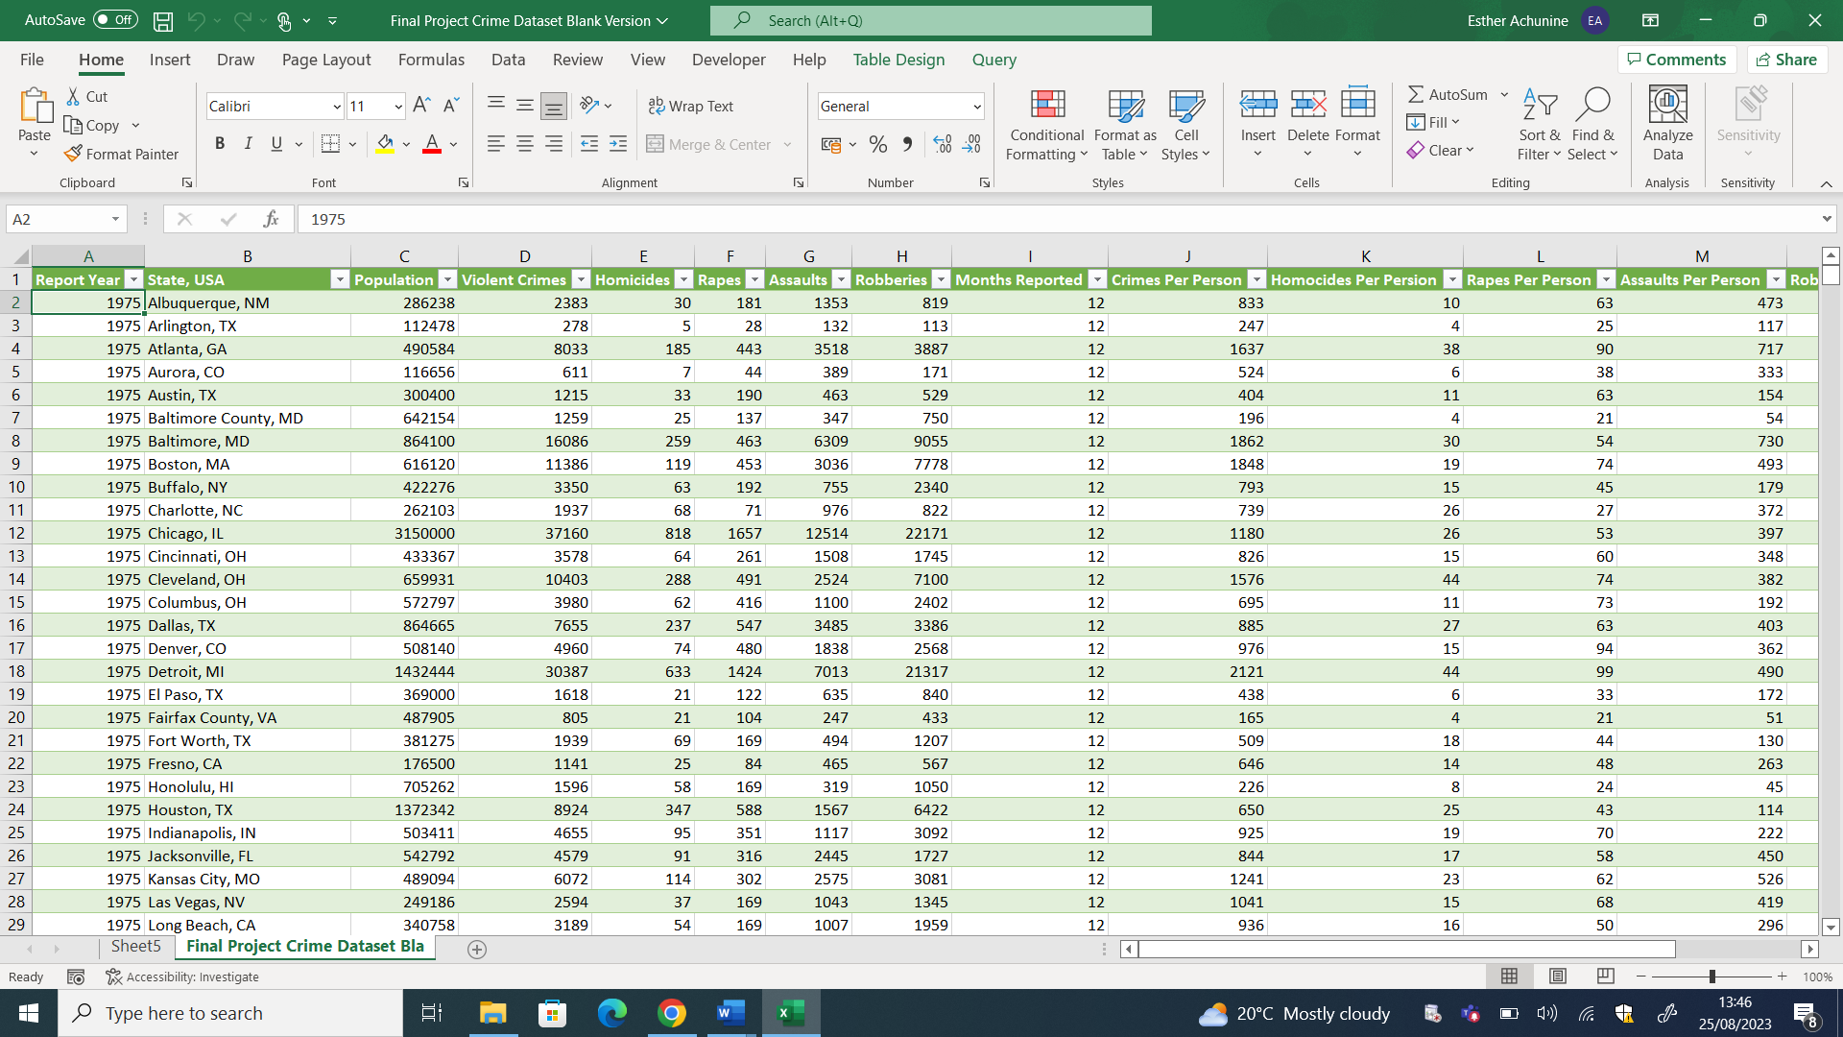

**STEP 3**

**After manipulating the data and cleaning the data on PowerQuery the data was ready to be aggregated by Formulas and Pivot tables.**

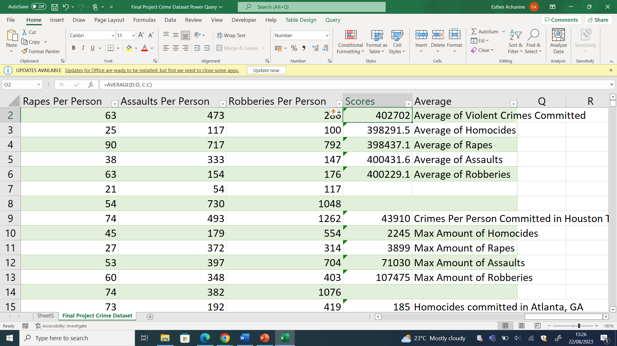

**STEP 4**

**I used the average formulae to find:**

* **Average of Violent Crimes Committed**
* **Average of Homicides**
* **Average of Rapes**
* **Average of Assaults**
* **Average of Robberies**

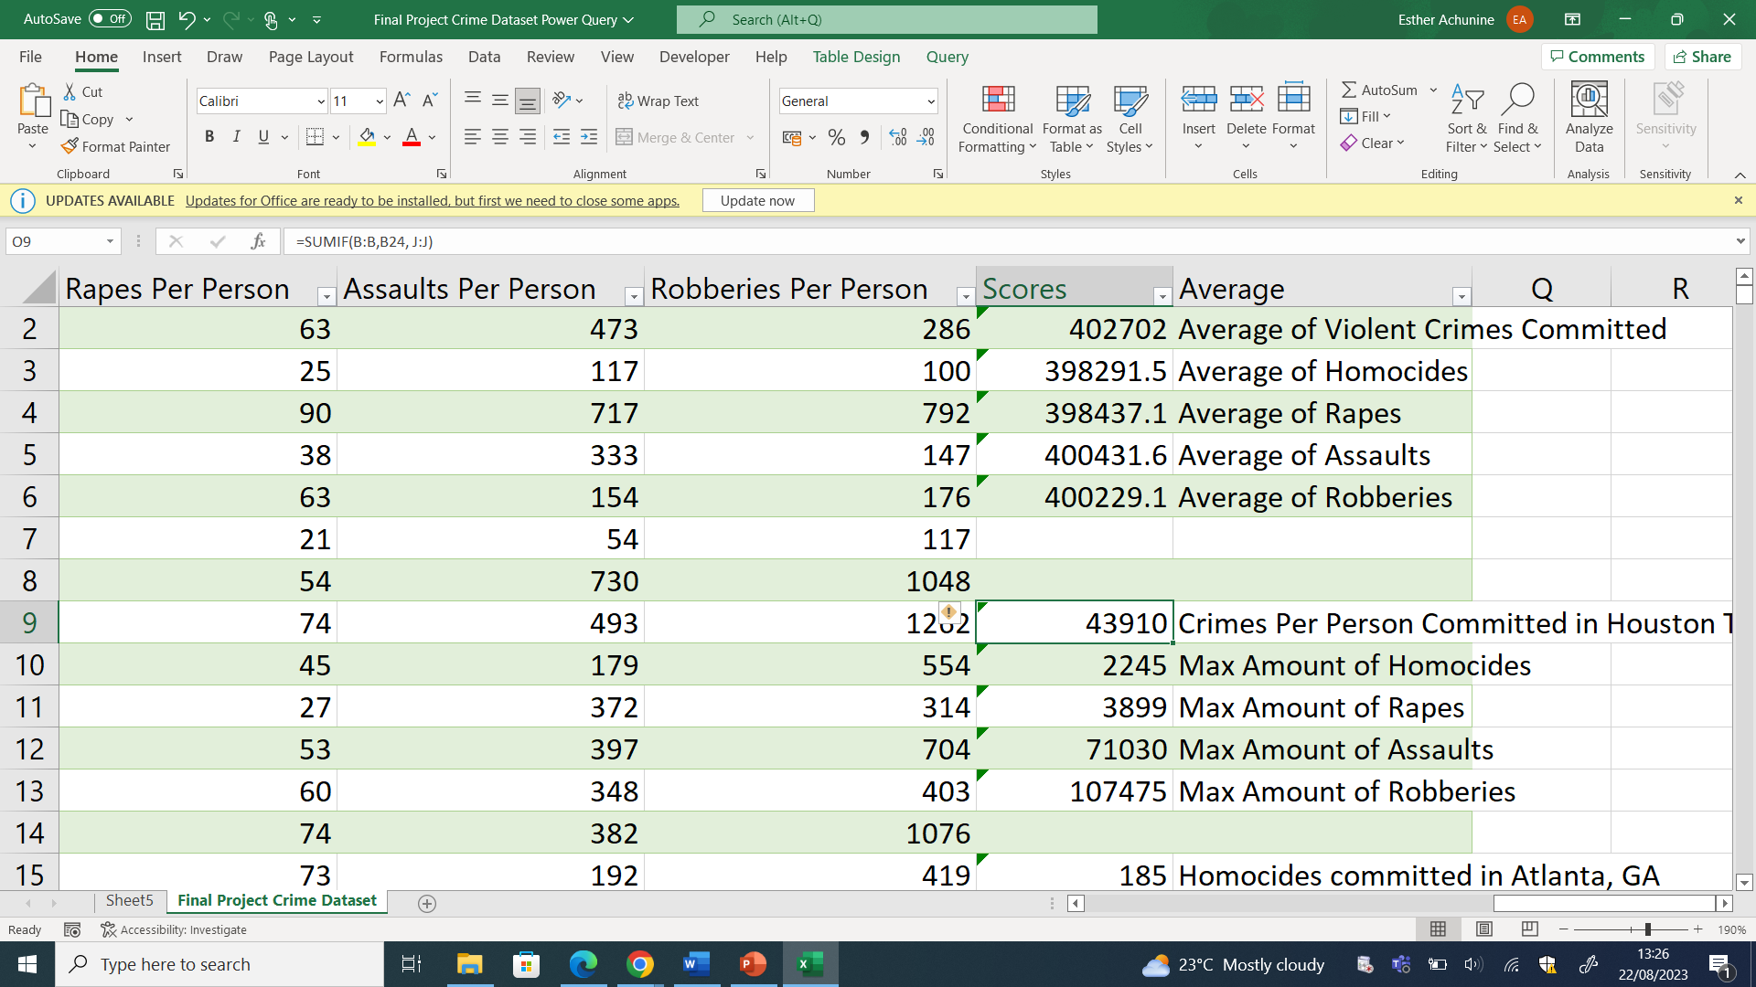

**STEP 5**

**I used the SUMIF formulae to find the crimes committed per person in Houston, Tx.**

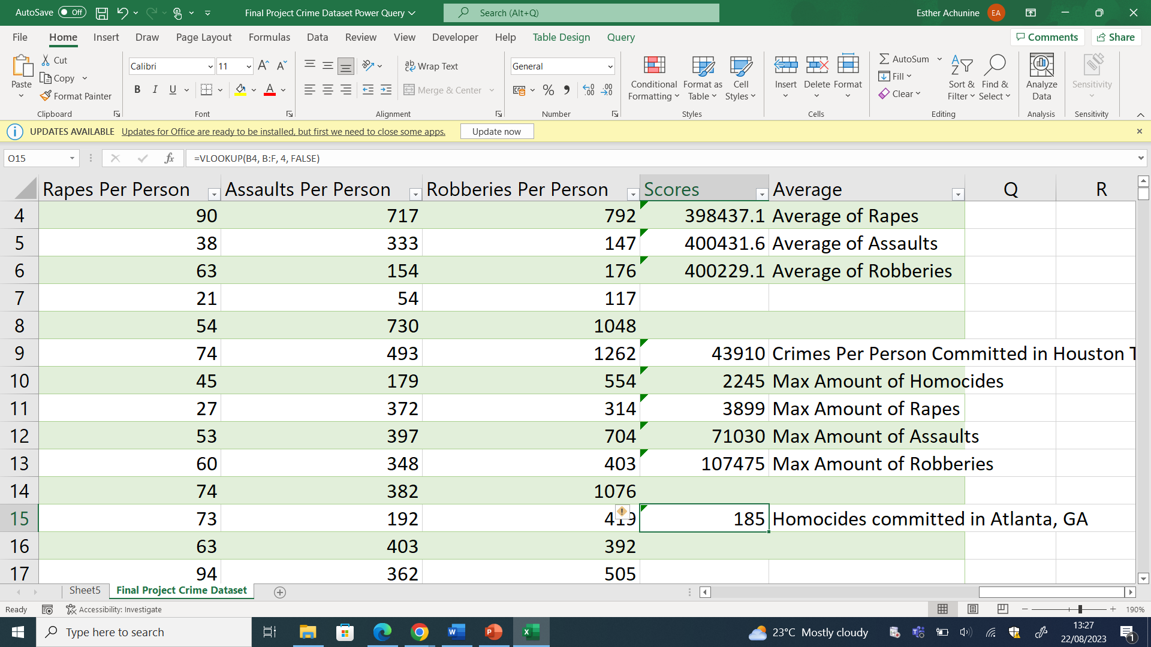

**STEP 6**

**I used the VLOOKUP formulae to find the Homocides committed in Atlanta, GA.**

|  |  |
| --- | --- |
| **Offences committed via Population** | **Sum of Scores** |
| Average of Assaults | 400431.61 |
| Average of Homocides | 398291.47 |
| Average of Rapes | 398437.15 |
| Average of Robberies | 400229.10 |
| Average of Violent Crimes Committed | 402702.22 |
| Crimes Per Person Committed in Houston Texas | 43910 |
| Homocides committed in Atlanta, GA | 185 |
| Max Amount of Assaults | 71030 |
| Max Amount of Homocides | 2245 |
| Max Amount of Rapes | 3899 |
| Max Amount of Robberies | 107475 |
| **Grand Total** | **2228835.554** |

**STEP 7**

**With the insights found within the dataset, I created a Pivot Table. This highlighted:**

* **Average of Assaults**
* **Average of Homicides**
* **Average of Rapes**
* **Average of Robberies**
* **Average of Violent Crimes Committed**
* **Crimes Per Person Committed in Houston Texas**
* **Homicides Committed in Atlanta, GA**
* **Max Amount of Assaults**
* **Max Amount of Homicides**
* **Max Amount of Rapes**
* **Max Amount of Robberies**